Session 13 – Archive Wei Cui

**Lab Objectives**

1. Follow the instructions for **Project 13-5: Viewing and Changing the Backup Archive Bit**.
2. Write a report including screenshots and written descriptions. Be sure to include a screenshot and description for step 6.

**Lab Results**

1. Started MS Word and create a document that contains my name and today’s date and saved as Bittest.docx as shown in Fig 1.
2. Clicked Start, entered cmd, and then pressed Enter. The Command Prompt window opens.
3. Navigate to the folder that contains Bittest.docx as shown in Fig. 2.
4. Typed attrib/? and displayed the options for this command as shown in Fig. 3.
5. Typed attrib Bittest.docx and displayed the attributes for this file. The A indicates that the bit is set and the file should be backed up.
6. Cleared the archive bit like the backup software does after it copies the file. Type attrib -a Bittest.docx and then pressed Enter.
7. Looked at the setting of the archive bit. Type attrib Bittest.docx and pressed Enter. The archive bit has been cleared.
8. I tried to add the archive bit by attrib +a Bittest.docx. It works. Step 5-8 are shown in Fig. 4

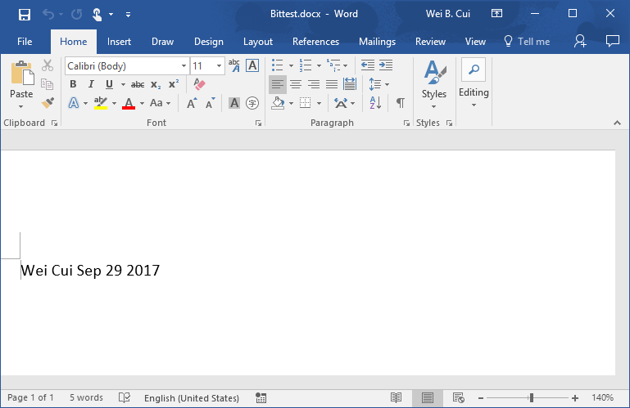

Fig. 1 A MS Word file contains my name and today’s date and saved as Bittest.docx.

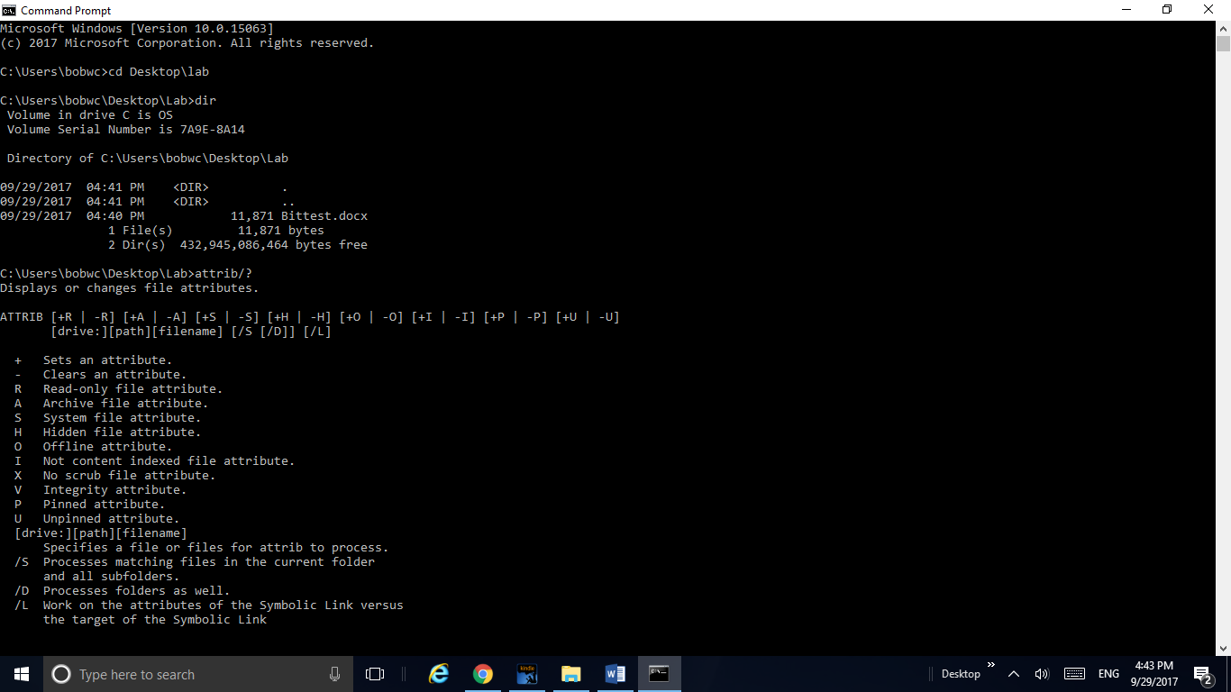

Fig. 2. Navigates to the folder that contains Bittest.docx in cmd.



Fig.3. Type attrib/? and display the options for this command.

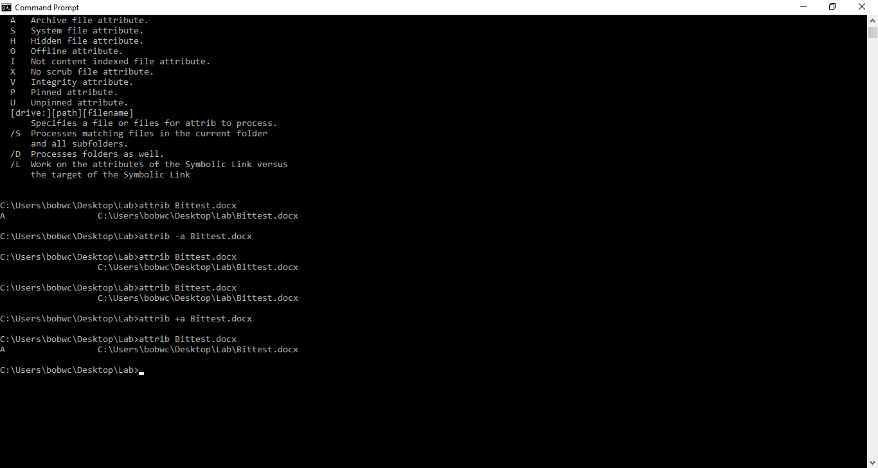

Fig.4. Displayed the archive bit by attrib Bittest.docx, cleared the archive bit by attrib -a Bittest.docx, added the archive bit by attrib +a Bittest.docx.